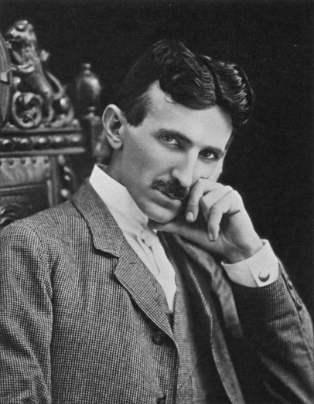
Nikola Tesla
Nikola Tesla (Serbian; 10 July 1856 – 7 January 1943) was an inventor, mechanical engineer, and electrical engineer.
Tesla was born to Serbian parents in the village of Smiljan, Austrian Empire near the town of Gospić, on the territory of modern-day Croatia. Nikola was the fourth of five children, having one older brother and three sisters. His family moved to Gospić in 1862. Tesla attended school at Higher Real Gymnasium in Karlovac. He finished a four-year term in the span of three years.
Tesla then studied electrical engineering at the Austrian Polytechnic in Graz (1875). While there, he studied the uses of alternating current. Some sources say he received a Bachelor’s degree from the university at Graz.
In 1882 he moved to Paris, to work as an engineer for the Continental Edison Company, designing improvements to electric equipment brought overseas from Edison's ideas. According to his autobiography, in the same year he conceived the induction motor and began developing various devices that use rotating magnetic fields for which he received patents in 1888.
United States
On 6 June 1884, Tesla first arrived in the United States, in New York City with little besides a letter of recommendation from Charles Batchelor, a former employer. In the letter of recommendation to Thomas Edison, Batchelor wrote, "I know two great men and you are one of them; the other is this young man." Tesla's work for Edison began with simple electrical engineering and quickly progressed to solving some of the company's most difficult problems. Tesla was even offered the task of completely redesigning the Edison company's direct current generators.
In 1886, Tesla formed his own company, Tesla Electric Light & Manufacturing. The initial financial investors disagreed with Tesla on his plan for an alternating current motor and eventually relieved him of his duties at the company. Tesla worked in New York as a laborer from 1886 to 1887 to feed himself and raise capital for his next project. In 1887, he constructed the initial brushless alternating current induction motor, which he demonstrated to the American Institute of Electrical Engineers in 1888. In the same year, he developed the principles of his Tesla coil, and began working with George Westinghouse. Westinghouse listened to his ideas for polyphase systems which would allow transmission of alternating current electricity over long distances.
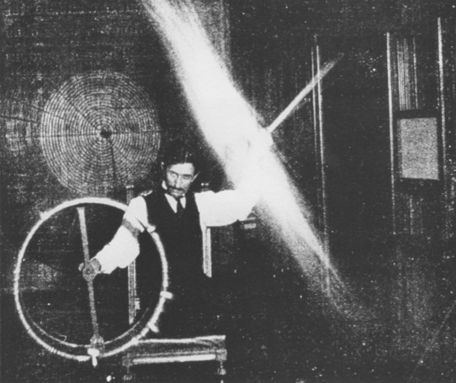
In April 1887, Tesla began investigating what would later be called X-rays using his own single terminal vacuum tubes. This device differed from other early X-ray tubes in that it had no target electrode. The modern term for the phenomenon produced by this device is bremsstrahlung (or braking radiation). By 1892, Tesla became aware of the skin damage that Wilhelm Röntgen later identified as an effect of X- rays.
From 1893 to 1895, he investigated high frequency alternating currents. He generated AC of one million volts using a conical Tesla coil and investigated the skin effect in conductors, designed tuned circuits, invented a machine for inducing sleep, cordless gas discharge lamps, and transmitted electromagnetic energy without wires, building the first radio transmitter. In St. Louis, Missouri, Tesla made a demonstration related to radio communication in 1893.

What experiments can you see on these photos?
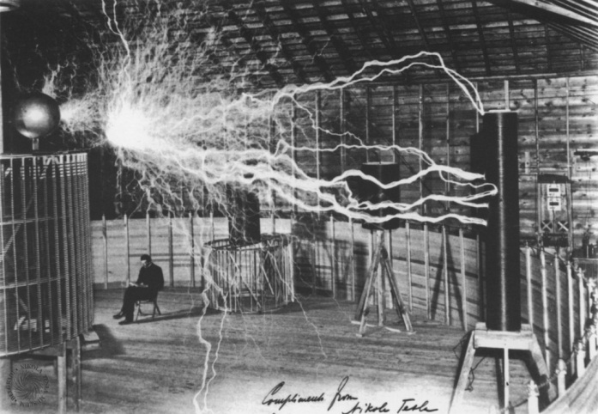
Experiments
In 1899, Tesla decided to move and began research work in Colorado Springs, where he would have room for his high-voltage, high-frequency experiments. Upon his arrival he told reporters that he was conducting wireless telegraphy experiments transmitting signals from Pikes Peak to Paris. At his lab, Tesla proved that the earth was a conductor, and he produced artificial lightning (consisting of millions of volts, and up to 135 feet long).
Tesla observed unusual signals that he later thought may have been evidence of extraterrestrial radio wave communications coming from Venus or Mars. He noticed repetitive signals from his receiver which were substantially different from the signals he had noted from storms and earth noise. There have even been claims that he invented a "Teslascope" for just such a purpose. It is debatable what type of signals Tesla received or whether he picked up anything at all.
Theoretical inventions
Later in life, Tesla made remarkable claims concerning a “teleforce " weapon . The press called it a "peace ray" or death ray . In total, the components and methods included.
Another of Tesla's theorized inventions is commonly referred to as Tesla's Flying Machine, which appears to resemble an ion-propelled aircraft. Tesla claimed that one of his life goals was to create a flying machine that would run without the use of an airplane engine, wings, ailerons, propellers, or an onboard fuel source. As time progressed, Tesla suggested that perhaps such an aircraft could be run entirely electro-mechanically. The theorized appearance would typically take the form of a cigar or saucer.
Death
Tesla died of heart failure alone in room 3327 of the New Yorker Hotel, on 7 January 1943. Despite having sold his AC electricity patents, Tesla died with significant debts. Tesla's funeral took place on 12 January 1943, at the Cathedral of Saint John the Divine in Manhattan, New York City. His body was cremated and his ashes taken to Belgrade, Serbia, then-Yugoslavia in 1957. The urn was placed in the Nikola Tesla Museum in Belgrade.
mechanical engineer | инженер-механик;
in the span | за период продолжительностью
electrical engineering | электротехника
alternating current | переменный ток
electric equipment | электрооборудование
induction motor | - индукционный двигатель  - асинхронный электродвигатель
rotating magnetic fields | вращающееся магнитное поле
a former employer | бывший наниматель
direct current generators. | генератор постоянного тока
alternating current motor | электродвигатель переменного тока
relieve smb. of duties | Освобождать от обязанностей
brushless alternating current induction motor | бесщеточный (вентильный) асинхронный двигатель переменного тока
Tesla coil | катушка Тесла
polyphase system | многофазная система
vacuum tubes | вакуумная трубка
target electrode | электрод-мишень антикатод
braking radiation | тормозное излучение
tuned circuits | резонансный контур
cordless gas discharge lamps | беспроводные газоразрядные лампы
artificial lightning | искусственные молнии
What invention is it?
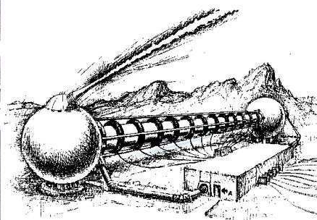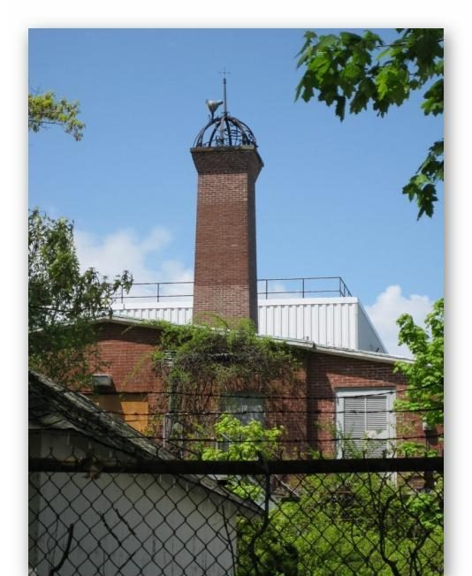
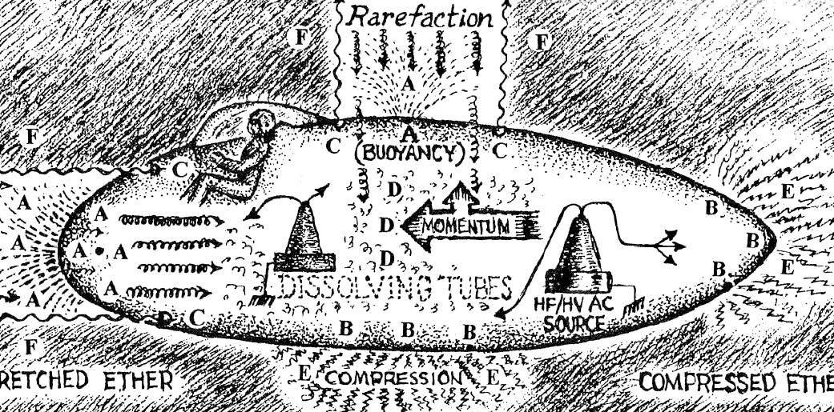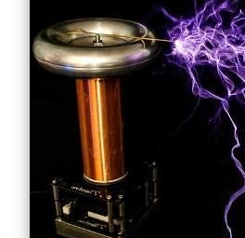

Answer the questions.
- What institute did N. Tesla study at?
- What did he do in New York to feed himself?
- What are his inventions?
- Did all his inventions have any practical use?
- Was he really talented? Prove it using the sentences from the text.

True or false?
- Tesla finished a four-year term in the span of two years.
- Tesla claimed that one of his life goals was to create a flying machine that would run without the use of an airplane engine, wings, ailerons, propellers, or an onboard fuel source.
- His body was cremated and his ashes taken to Belgrade, Serbia, then-Yugoslavia in 1967.
- By 1892, Tesla became aware of the skin damage that he later identified as an effect of X- rays.
- Nikola was the fourth of five children, having one older brother and three sisters.

