**Практическая работа №21-1**

**«Знакомство с комплектом аппаратуры. Характеристики приемника»**

1. Изучить комплектность прибора

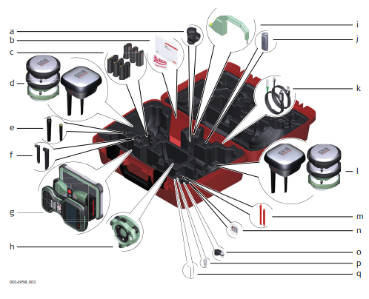

Рисунок 1 – Контейнер для прибора GS и аксессуаров ½

a ________________________

b ________________________

c ________________________

d ________________________

e ________________________

f ________________________

g ________________________

h ________________________

i ________________________

j ________________________

k ________________________

l ________________________

m _______________________

n ________________________

o ________________________

p ________________________

q ________________________

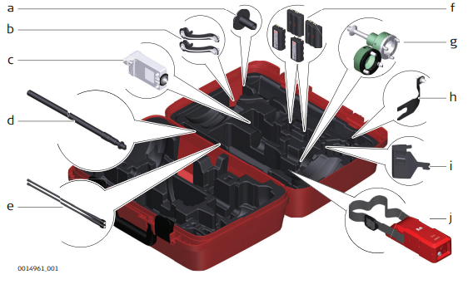

Рисунок 2 - Контейнер для прибора GS и аксессуаров, 2-ая часть

a ___________________________________________________________

b ___________________________________________________________

c ___________________________________________________________

d ___________________________________________________________

e ___________________________________________________________

f ___________________________________________________________

g ___________________________________________________________

h ___________________________________________________________

i ___________________________________________________________

j ___________________________________________________________

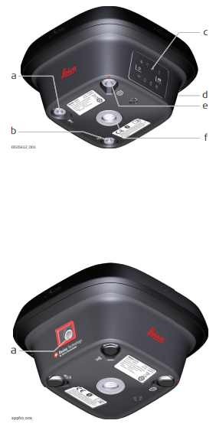

Рисунок 3 – Компоненты GS18

a ____________________________________________________________

b ____________________________________________________________

c ____________________________________________________________

d ____________________________________________________________

e ____________________________________________________________

f ____________________________________________________________

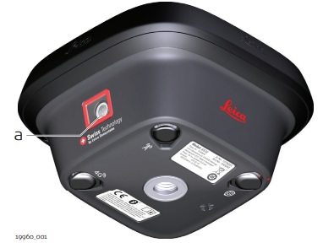

Рисунок 4 Компоненты GS18

a ___________________________________________________________

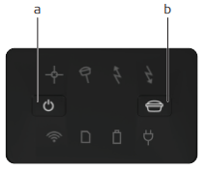

Рисунок 5 – Клавиатура 18

a ___________________________________________________________

b ___________________________________________________________