**Варианты заданий к лабораторной работе №14**

**К задаче №1**

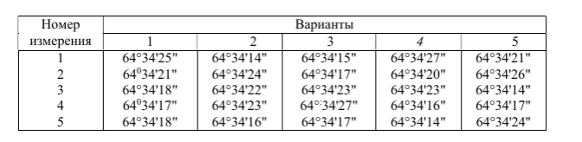

**К задаче №2**

|  |  |  |  |  |  |  |
| --- | --- | --- | --- | --- | --- | --- |
| Номер  измерения | Вариант | | | | | |
| 1 | 2 | 3 | 4 | 5 | 6 |
| 1 | 26°34'20" | 26°34'48" | 26°34'21" | 26°34'17" | 26°34'13" | 26°34'52" |
| 2 | 26°34'10" | 26°34'45" | 26°34'18" | 26°34'14" | 26°34'08" | 26°34'50" |
| 3 | 26°34'15" | 26°34'40" | 26°34'20" | 26°34'10" | 26°34'05" | 26°34'55" |
| 4 | 26°34'12" | 26°34'50" | 26°34'22" | 26°34'09" | 26°34'11" | 26°34'49" |
| 5 | 26°34'21" | 26°34'42" | 26°34'17" | 26°34'20" | 26°34'20" | 26°34'47" |
| 6 | 26°34'14" | 26°34'47" | 26°34'15" | 26°34'21" | 26°34'16" | 26°34'57" |

**К задаче №3**

|  |  |  |  |  |  |  |
| --- | --- | --- | --- | --- | --- | --- |
| Номер  измерения | Вариант | | | | | |
| 1 | 2 | 3 | 4 | 5 | 6 |
| 1 | 26°34'20" | 26°34'48" | 26°34'21" | 26°34'17" | 26°34'13" | 26°34'52" |
| 2 | 26°34'10" | 26°34'45" | 26°34'18" | 26°34'14" | 26°34'08" | 26°34'50" |
| 3 | 26°34'15" | 26°34'40" | 26°34'20" | 26°34'10" | 26°34'05" | 26°34'55" |
| 4 | 26°34'12" | 26°34'50" | 26°34'22" | 26°34'09" | 26°34'11" | 26°34'49" |
| 5 | 26°34'21" | 26°34'42" | 26°34'17" | 26°34'20" | 26°34'20" | 26°34'47" |
| Число  приёмов |  |  |  |  |  |  |
|  | 3 | 5 | 4 | 3 | 3 | 5 |
|  | 4 | 2 | 4 | 3 | 5 | 4 |
|  | 3 | 2 | 3 | 4 | 1 | 3 |
|  | 1 | 3 | 1 | 2 | 1 | 2 |
|  | 2 | 2 | 1 | 2 | 2 | 1 |