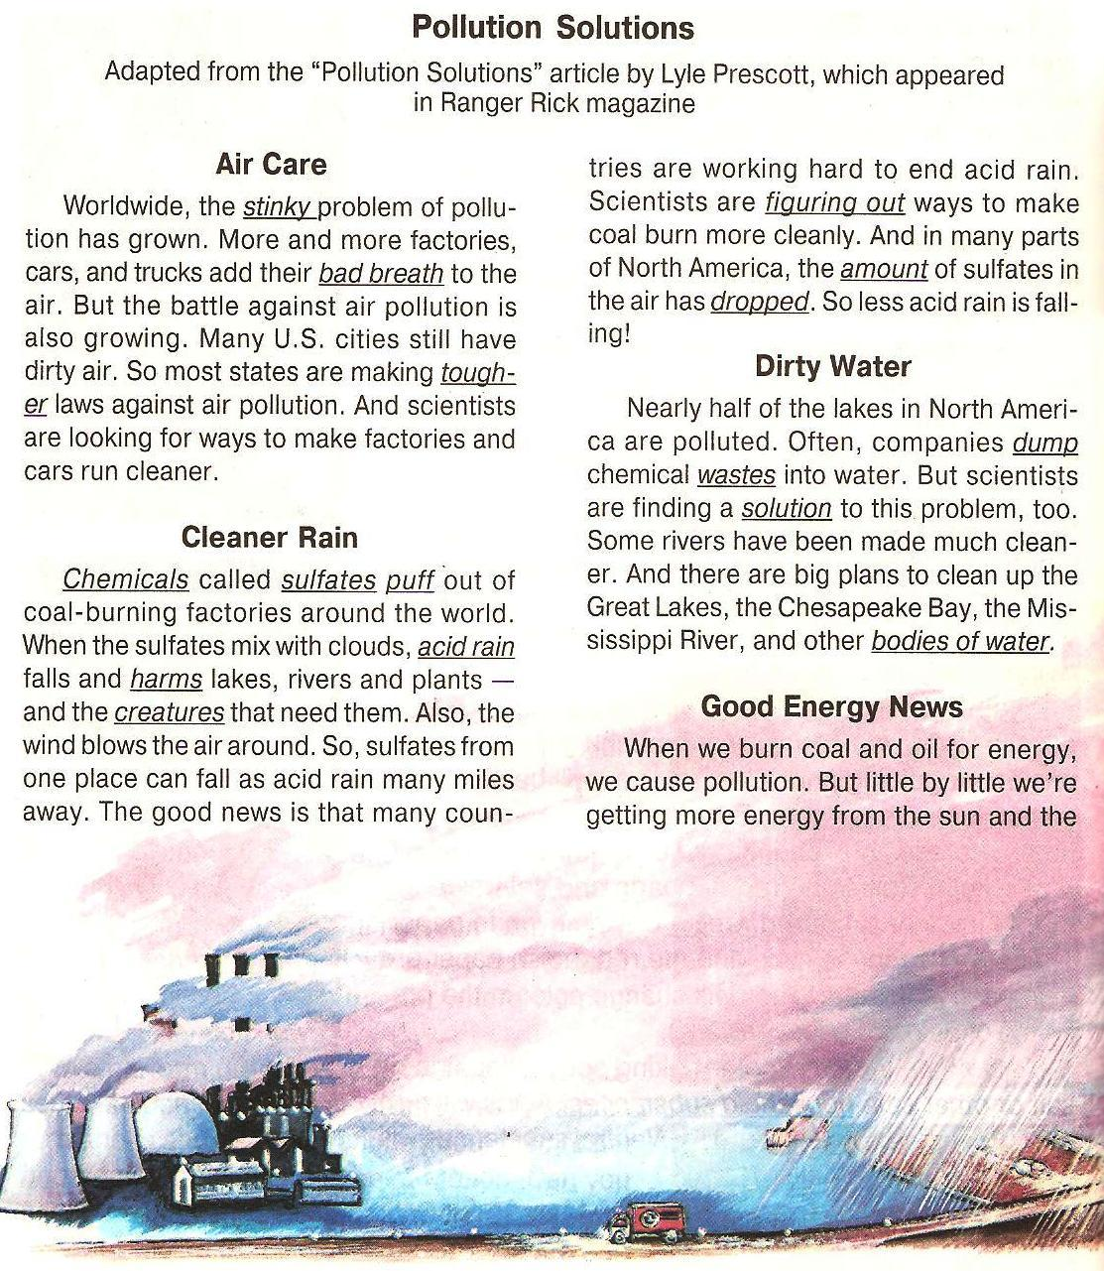
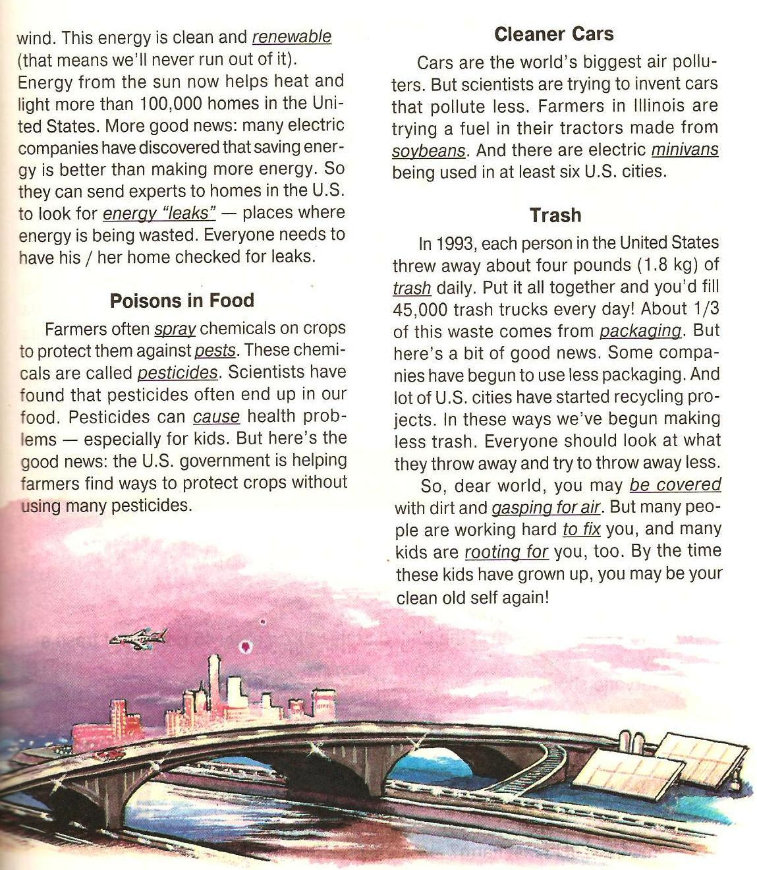
№1. Match the words in Column A with the words or phrases in Column B that best describe them.
Column A Column B
1stinky a) _ to throw down, unload
2sulphate b) _ insect, bug
3acid rain c) _ every day
4to figure out d) _ a chemical
5pest e) _ to cheer for
6single f) _ to learn how
7daily g) _ bad smell
8to root for h) _ sulphate mixed with clouds
9to dump i) _ one

№2. True or False?
- Many U.S. cities have dirty air.
- Most of the states in America don’t have laws against air pollution.
- Scientists are looking for ways to make factories and cars run cleaner.
- Sulfates come out of coal-burning factories only in America.
- Nobody cares about acid rain.
- All of the lakes and rivers in America are polluted.
- Energy is renewable.
- Pesticides can often be found in food.
- Cars don’t cause air pollution.
- In 1993, each person in The United States threw away 45 pounds of trash a day.
- Everyone should throw away less trash.
№ 3 Fill in all the gaps
pollution, rubbish, cans, environment, packaging, protect, is thrown, in danger, prohibited, pollute, bins, clearing up.
People get a lot of food from the sea. Nevertheless, we have made the sea a very dirty place. If we are not careful .......... will kill many of the animals and plants in the sea. A lot of rubbish .......... into the sea. Sea animals, fish and birds are .......... . Some animals try to eat the ........... , they die. Oil from the ships, chemicals and waste ........... the sea and kill whales and dolphins, fish and sea birds.
Luckily, many people realize now that we must look after the sea and .......... it. They say polluting the sea should be strictly........... Groups of people who care about the .......... spend their free time clearing up litter from the beaches. People collect ........... , bottles and .......... and put them into different .......... for further recycling.
№ 4 Choose the correct word to fit into each sentence. Make necessary changes.
to pollute, pollution
a) The water ____ here. You cannot swim.
b) This factory ____ the air.
c) Fish die because of water ____.
to protect, protection
a) You can ____animals if you send money to
the World Wildlife Fund.
b) The _____of animals is the aim of the World Wildlife Fund.
3) to recycle, recyclable
a) Buy only_____goods.
b) Can you _____these plastic containers?
4) to collect, collection
a) His _____of stamps is very big.
b) He _____toy animals.

