CANADA
Canada is an independent federative state. It is one of the most developed countries. Canada consists of ten provinces and two territories.
It is situated on the North American continent. The country is washed by the Pacific Ocean in the west, by the Atlantic Ocean in the east and by the Arctic Ocean and its seas in the north. About 2 percent of the Canadian territory is covered by glacier ice.
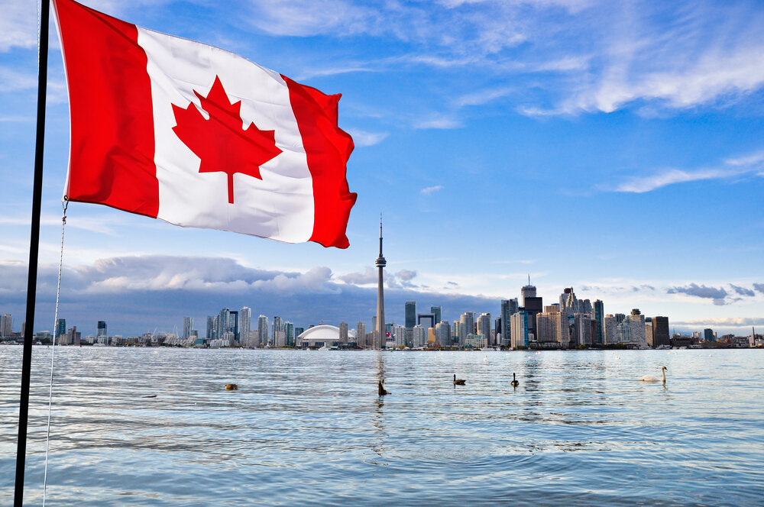
The eastern parts of the country are mainly valleys and plains. The western territories are occupied by the Cordilleras.
The main Canadian islands are Newfoundland, Victorian Island, Baffin Island and others. There are a lot of rivers and lakes in Canada. The largest rivers are the Nelson, the Ottawa, the Mackenzie and the Yukon.
In size Canada is the second in the world after Russia. Its area is almost 10 million km2. The capital of Canada is Ottawa, which is situated on the bank of the Ottawa River. It is famous for its beautiful parks. It is also known as the city of bridges.
The most developed industries are timber, mining, chemical, meat and milk and food industries. Canada grows wheat, barley, flax, potatoes, vegetables and fruit. Fishing is also one of the prosperous industries.
Official languages of Canada are English and French. Canada is a founding member of the United Nations. It has been active in a number of major UN agencies.
1) Read these geographical names.
- Canada
- the North American continent
- the Pacific Ocean
- the Atlantic Ocean
- the Arctic Ocean
- Canadian islands
- Newfoundland [‘njuːfən(d)lənd]
- Victorian Island
- Baffin Island
- the Nelson, the Ottawa, the Mackenzie and the Yukon
2) Remember the words.
independent federative state – независимое федеративное государство
the most developed – наиболее развитый
provinces - провинции
territories - территории
the west - запад
the east - восток
percent - процент
is covered - покрыты
glacier ice - ледник
are occupied by - заняты
bank - берег
bridge - мост
timber – лесная промышленность
mining – горная промышленность
chemical – химическая промышленность
wheat - пшеница
barley - ячмень
flax - лен
prosperous - процветающий
founding member - основатель
United Nations – Организация Объединенных Наций
major UN agencies – основные учреждения ООН

3) Make up these sentences.
1) on the North American continent / is / it / situated.
2) a lot of / there are / in Canada / rivers and lakes .
3) of Canada / are / English and French / official languages.
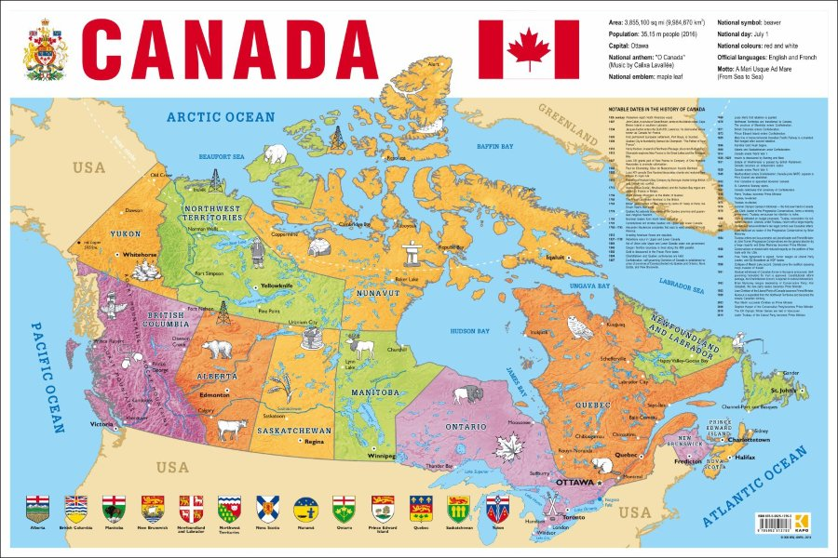
4) consists of / Canada / ten / territories / and / provinces / two.
4) Answer the questions.
1. What does Canada consist of?
2. Where is it situated?
3. What oceans is Canada washed by?
4. What are there in the eastern part of the country?
5. What are the main Canadian islands?
6. What are the largest rivers?
7. What is the size of Canada?
8. What is its area?
9. What is the capital of Canada? Where is it situated? What is it famous for?
10. What are the most developed industries?
11. What are grown in Canada?
12. What are the official languages?
5) Do the test.
1. Fill in the missing words.
Largest / flax / continent / an / eastern / Ocean / parks / provinces / developed / western
Canada is 1) … independent federative state. It is one of the most 2) … countries. Canada consists of ten 3) … and two territories. It is situated on the North American 4) …. The country is washed by the Pacific 5) … in the west. The 6) … parts of the country are mainly valleys and plains. The 7) … territories are occupied by the Cordilleras. The 8) … rivers are the Nelson, the Ottawa, the Mackenzie and the Yukon. Ottawa is famous for its beautiful 9) …. Canada grows wheat, barley, 10) …, potatoes, vegetables and fruit.
2. True or false.
1) Canada is the most developed country.
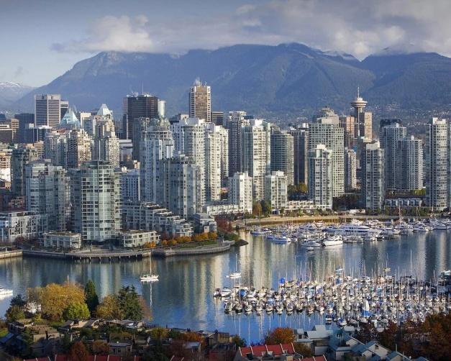
2) Canada consists of two provinces and ten territories.
3) It is situated on the South American continent.
4) The country is washed by the Arctic Ocean in the south.
5) The largest rivers are Newfoundland, Victorian Island, Baffin Island and others.
6) In size Canada is the first in the world.
6) Quiz.
- 1. Canada is surrounded by ___ oceans.
A. 1 B. 2 C. 3 D. 4
- 2. What is the capital of Canada?
A. Ottawa B. Québec C. Vancouver D. Montreal
- 3. Canada's national animal is the...
A. Grizzly bear. B. Moose. C. Beaver. D. Eagle.
- 4. Canada owns ___% of the world's forests.
A. 5 B. 10 C. 15 D. 20
- 5. Who were the first inhabitants of Canada?
A. American people B. Aboriginal people C. European people D. Eskimos
- 6. Ice hockey is the national winter sport of the country. What is the national summer sport?
A. Lacrosse B. Basketball C. Football D. Rugby
- 7. Niagara falls belongs to...
A. Canada. B. The USA. C. Both of them. D. None of them.
- 8. How big is the population of the country?
A. More than 10 million people B. More than 20 million people C. More than 30 million people
D. More than 40 million people
- 9. In 2010 the Winter Olympic Games were held in Vancouver. There was another occasion when Canada was a host for the games. When was it?
A. 1948 B. 1956 C. 1976 D. 1988

